Impact of the Digital Divide on Different Demographic Groups
Prepared by:

Roozbeh Arshadi –. 98166514
Joseph Chan –. 98144048
Eileen Chen –. 98170437
Wandee Lee –. 98147537
David Maslach –. 98090308
Douglas Paul –. 98321024

For:
Dr. A. Berczi
MSci 442

January 30, 2002

Executive Summary
The digital divide is an increasing global concern that affects all demographic categories. This report analyses several demographics, including income, education, race, gender, age, people with disabilities, and geography, in an attempt to isolate and provide solutions to problem areas that are causing the gap to increase.
Income is an extremely important demographic that is very useful in understanding the reason behind the digital divide. It is arguably the most important factor above all other categories that were examined in this report, as the level of income affects almost all other demographic categories. It has been reported that the largest divide occurs between different levels of income. As the level of income increase, so does the percentage of households with Internet access. Government funding is required in this area in order to help bridge the gap.
Education is another important demographic that is used to determine the cause of digital divide. Those with higher levels of education have a higher access to information technology. Though it is important to have access to IT, it is also extremely important to integrate the use of this technology into the school curriculum. Also, it has been shown that poorer schools are less likely to be connected to the Internet than richer schools. Because of this, government funding and proper training are required to help the divide in this category.
The third demographic category studied is the division amongst different racial and ethnic groups. It has been reported that Whites and Asians/Pacific Islanders are more likely to use the Internet than First Nations, Blacks, and Hispanics. Though this is true, many argue that the reason behind this discrepancy is due to income, and not to racial background. Therefore, it is perhaps better not to force a racial divide in an issue that should not have anything to do with race, but rather with other demographic categories.
Another demographic used to study the digital divide is gender. Presently, women are behind men when it comes to the use and access of information technology. Whether it be due to societal views of women, the women’s own belief of gender roles, or some other factor, the division does exist in this category. To bridge the gap between women and men, the gender role norms should be analysed further.
Age is also considered in this report as a demographic category. It has been clearly shown that the availability and impact of the Internet is different for teens of 17 or younger, young adults from 18 to 49, and seniors of 50+. Because the American society has emphasized the importance of educating the young on the use of the technology, most teens get exposure to computers and Internet through school settings. Aging baby boomers and senior citizens are the least likely to have access to the Internet. Improving the availability of computers to the seniors as well as educating them on the use of the technology would help decrease the digital divide among this age group.
People with disabilities are also used as a demographic category for studying the digital divide. This problem is mainly due to a lack of technology that focuses on their special needs. Auxiliary aids available include taped texts, brailled materials, large print materials, captioning and other methods of making audio and visual media available to people with disabilities. More must be done to advance technology so that the access and effectiveness is equal to those with and without a disability.
Finally, geography is used as a demographic in order to analyse the digital divide. While penetration of information technology is increasing in the inner city, it is at a much lower rate than both urban and rural regions. Government subsidies are currently used to eliminate the divide between rural and urban areas. Developing nations have their own unique barriers to Internet access, which is mainly their infrastructure. The current solutions to the global problem have come in the form of foreign aid.
The digital divide affects all demographic categories in the same manner, though some demographics are affected more than others. They all are affected by the way they communicate, by access to the unique job opportunities, personal development available on the Internet, and the convenience and access to information that is achievable if connected.

Table of Contents
Executive Summary ii
1 Introduction 1
2 Research Findings and Analysis 2
2.1 Income 2
2.2 Education 4
2.3 Race and Ethnic Origin 6
2.4 Gender 9
2.4.1 Environmental Factors 9
2.4.2 Higher Education and Career Factors 10
2.5 Age 11
2.6 People with Disabilities 12
2.7 Geography 14
3 Conclusions 18
4 Recommended Future Research 19
References 20
Appendix A: Presentation Slides 23

- Introduction

Equal access to information technology has been an increasing concern for developed and under-developed countries. Yet, unequal access to any kind of technology has always existed in society. As with the use of the telephone by upper middle class society in the early 1900’s, computers and Internet access is unequally distributed in the second millennium. [16] In a 1998 study by Statistics Canada [10], the households with the top quartile of income were twice as likely to use computers than the bottom quartile. Especially in the latter part of the 20th century, there has been a call for the eradication of inequality by government and civil rights movements.
This disparity between the haves and the have-nots is not likely caused by outright discrimination, but more so by several innate factors. For example, the historical context of the Internet and computers may play a large role in the computer access inequality. The Internet first started as a military effort to pass information between academia and high-ranking officers. Thus, the upper-middle class had the first start at using the Internet because academia and military officers tend to be in the higher classes of society. [2]
Nevertheless, the inequality in Information Technology (IT), dubbed the ‘digital divide,’ should be the focus of debate and discussion. This report will focus on the different demographic categories that are affected by the digital divide. These categories include income, education, race, gender, age, people with disabilities, and geography. Each category will be examined with a strong North American focus, but will also be examined on a larger global scale relating to the digital divide.

- Research Findings and Analysis

Income
In North America, the digital divide is most prominent among the different levels of income. According to 1998 and 2000 studies performed by the US Department of Commerce's National Telecommunications and Information Administration (NTIA), there is a significant gap between the high-income and low-income U.S. households with access to the Internet. The studies show that Internet access has risen in every level of income, as shown in Figure 1. U.S. households with income under $15000 have risen from 7.1% to 12.7%, while for families with income over $75000, the percentage has risen from 60.3% to 77.7% [30]. This also shows that the disparity remains quite large between high and low-income households.

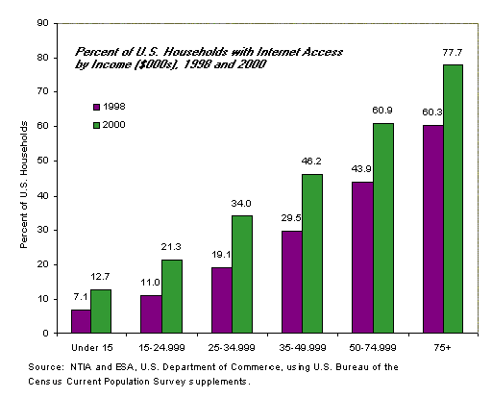
Figure 1: US Households with Internet Access, by Income [30]

One of the reasons low-income families have less opportunity to Internet access is due to the lack of telecommunications infrastructure available in poor neighbourhoods. Telecommunication facilities are more readily available for wealthier communities. Poverty in less fortunate neighbourhoods make them less appealing for investments by outside companies, further aggravating the divide.
Income also plays a prominent role in the access speed of Internet users. It is evident that people with more money will have greater access to broadband, or high-speed, networks. In August 2000, 10.7% of online households have broadband access. The remaining 89.3% of online households connect to the Internet by regular dial-up phone service.
The most frequent online activity among Internet users in August 2000 is e-mail, regardless of income. Other activities common among all income groups are searching for information and checking news. Low-income Internet users spend more of their time visiting education, government, and job-search sites, as shown in Figure 2. [21] Low-income populations see the Internet as a career enhancement vehicle that can give them a better opportunity in the 21st century. High-income users frequent news, financial and business sites. They view the Internet as a convenience in their everyday life.
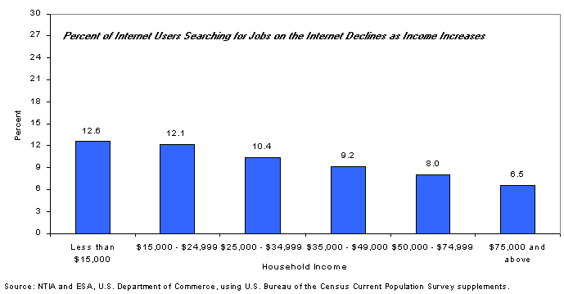
Figure 2: Internet Job Searching Relative to Income [30]

The U.S. government has taken initiatives to help bridge the digital divide. In order to provide new opportunities for all Americans, a $2 billion tax incentive program was proposed to encourage private sector donation of computers, and to create training facilities and programs. Specifically, the U.S. government is to provide $100 million to create up to 1000 community technology centres in low-income urban and rural communities. These new technology centres offer access to high-quality educational software to low-income children and supply literacy, technical training programs and Internet access for adults. In addition, $50 million is go to expanding home access to computers and the Internet for low-income families. This includes high-tech companies providing discounts on computers and supplying local libraries with computers with Internet capabilities [7].

Education
The topic of literacy and education as it pertains to the 'Digital Divide' is multifaceted. This section will concentrate on three important areas. First, it will examine the trend that individuals with higher levels of education have more access to information technology than those with lower academic attainment. Also, the importance of integration of technology into school curriculum is discussed, emphasizing the fact that access to computers should be complemented with proper training in order to be effective. Finally, the issue of equity in schools as it pertains to use of information technology is discussed.
A U.S. Department of Commerce survey from the Fall of 2001 indicates that nearly 65% of college graduates have home Internet access, and only 11.7% of households headed by persons with less than a high school education have Internet access [11]. Also, according to studies performed by the US Department of Commerce's National NTIA in both 1998 and 2000, Internet usage rates increase dramatically with the level of educational attainment, as shown in Figure 3. [30]. These findings should hardly come as a surprise. In general, an individual with a higher educational attainment would have a greater income and therefore is more likely to own a computer and have access to the Internet. Also, he or she is more likely to be better trained and educated with regard to information technology. Although not entirely surprising, these facts do have a great socio-economic impact. Within the next several years, nearly half of all jobs will either be in the IT industry or will require IT-related skills [12]. Therefore, it is important that even those individuals who have not been exposed to technology through their education acquire the necessary skills to take on these positions. A solution to this problem would be placing more emphasis on adult education programs where IT related skills are taught.
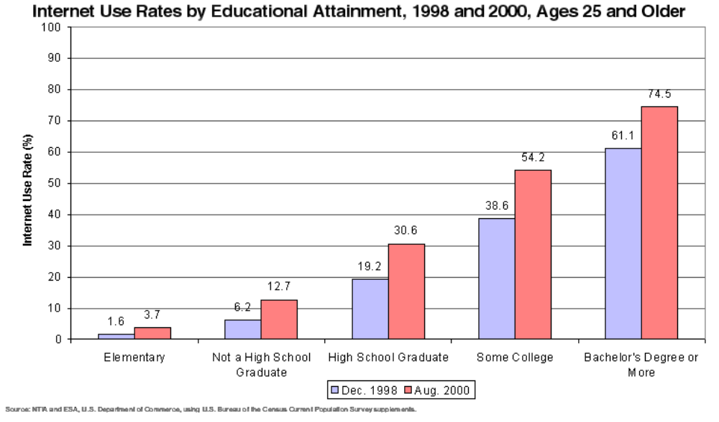 Figure 3: Internet Use Rates by Educational Attainment [30]

Another important issue is the incorporation of technology into the education system. This issue has been identified and there have been many attempts to remedy the problem, especially in North America. However, it seems that in many cases the implemented solution is merely 'dumping more computers' into schools without the necessary support, training, and incorporation into the curriculum. Providing the necessary equipment is certainly a step in the right direction; however, it is not enough. In recent years, programs such as E-rate in the United States have helped to increase computer to student ratios in American schools [6]. E-Rate was created as part of the Telecommunications Act of 1996 to provide discounts on the cost of telecommunications services and equipment to all public and private schools and libraries [6]. However, as mentioned before, giving kids more computers in schools is not enough. For example, when Apple handed out 23,000 iBooks in the Fall of 2001 to schools in Henrico County, Virginia, the computers became a distraction rather than a learning tool. "It's basically a $1,200 CD player and a Game Boy," said one student. [9] However, there are also examples of success where purchase of new equipment in combination with proper support and training yielded astounding results. In 1996, Boston had a student-to-computer ratio of 63-to-1. Only 5 to 10 percent of teachers had computers, but few, if any, computers were used in the classroom. A couple of schools had dial-up access to the Internet. [30] In 2001, Boston has 130 networked schools, a computer-to-student ratio of 1-to-6, 65 percent of its teachers trained in the effective classroom use of technology, 1,500 students enrolled in certified technology classes, 26 networked libraries and 100 networked community centres [29]. This amazing feat was accomplished with a great deal of public and private funding in combination with proper support, training, and resources from various companies.
The third issue is the issue of equity with respect to access to information technology in schools. Poorer schools are less likely to be connected to the Internet than richer schools. The National Center for Education Statistics reports that Internet access is available in only 53 percent of schools where more than 70 percent of students are eligible for the government's free lunch program, while 78 percent of the schools with less than 11 percent of eligible students are connected [8]. Even though programs such as E-rate have attempted to narrow the gap by giving greater discounts to needy schools, the problem still remains. It remains because even though the poorer schools do get more computers, they rarely have the resources to support them. Another problem is the difference in culture between the richer and the poorer schools. For example in many urban schools in the United States, the computers are there; however, the technology is not used. Also, many reports suggest that students in wealthier schools are more likely to use computers to develop analytical skills, while the kids in poorer districts use them mostly for routine, repetitious tasks [8]. In a culture where the ability to use technology is one of the most important skills required for higher-paying jobs, the kids in the poorer districts will therefore lag behind. They will not have the same opportunities as the students in richer schools. They will be forced to take on low-wage jobs, therefore further increasing the income gap. There are no easy solutions to this problem. Even if we provide more funding to poorer schools for acquisition of computers, resources will be needed to train teachers and to incorporate technology into the curriculum. In schools where there is not even enough funding to hire an adequate number of teachers, allocating resources to technology will not be easy.

Race and Ethnic Origin
A person’s race or ethnic origin is another demographic category that can be used to analyze the effect of digital divide. Several surveys have shown that there are differences between the level of Internet usage when comparing the person’s race or ethnic background. A 1998 survey administered by the National Telecommunications and Information Administration (NTIA) clearly illustrates these differences.
As shown in Figure 4 below, Whites (37.7%) and Asians/Pacific Islanders (API) (35.9%) use the Internet much more than Blacks (19.0%) and Hispanics (16.6%). Only Asians/Pacific Islanders and Whites have relatively greater access at home, while First Nations (also referred to as AIEA), Blacks, and Hispanics more often turn to access outside the home. In fact, Whites are more likely to have access to the Internet from home than Blacks or Hispanics have from any location. [25]
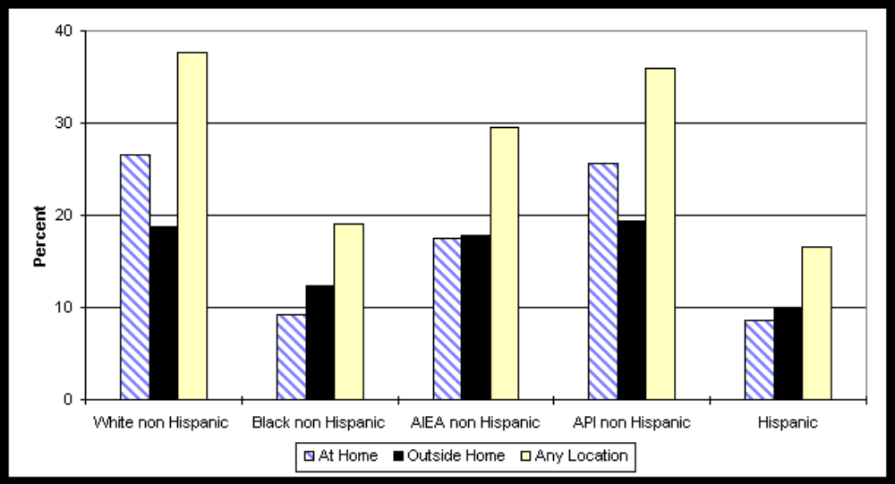
Figure 4: Percent of US Persons Using the Internet By Race/Origin and Location [25]

The reasons given for households with a computer or WebTV not connecting to the Internet at home, surveyed from the same sample as mentioned above, are given in Figure 5. The cost factor is most important to Hispanics (23.4%), surpassing the "don't want it" response (19.6%). However, the "don't want it" reason ranks higher than cost in the case of Whites (26.7% versus 15.6%), Blacks (24.0% versus 22.0%), and "Other" (21.8% versus 17.4%). The reason "can use elsewhere" is much less important to all except for "Other non Hispanic" households (15.1%). [25]
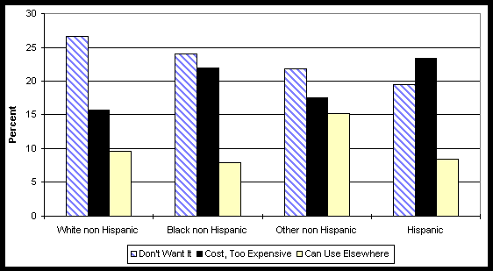
Figure 5: Reasons for Households with a Computer/WebTV Not Using the Internet at Home By Race/Origin [25]

In another survey administered by CommerceNet/Nielsen Internet Demographic Study (IDS), it has been noted that the income of each household explains race differences in home computer ownership. However, education is the main reason for this discrepancy in Internet access and use between races and ethnicities. Thus, to ensure that the digital divide decreases among different races, participation is required from everyone in the information revolution, and therefore it is critical to improve the educational opportunities for minorities. [27]
Although the digital divide amongst different races and ethnic origins has been growing, for Americans with incomes of $75,000 and higher, the divide between Whites and Blacks has actually narrowed considerably. This finding suggests that the most affluent American families, irrespective of race, are connecting to the Internet. It is therefore a possibility that, if prices of computers and the Internet decline further, the divide between the information haves and have-nots may continue to narrow. [25]
This brings up a controversial issue regarding whether race is in fact a determining factor for access and usage of the Internet. Many believe that money is the most important factor of all. “The digital divide is far more about class than race”, as stated by a vocal group of black technology executives. [17] Those who believe this argue that “depicting blacks as hopelessly behind may hurt African-Americans” [17], and that comparing different races could actually do more harm than good. "The rhetoric of the digital divide holds open this division between civilized tool-users and uncivilized nonusers," says Henry Jenkins, director of comparative media studies at the Massachusetts Institute of Technology. "As well-meaning as it is as a policy initiative, it can be marginalizing and patronizing in its own terms." [35]
Therefore, if there was anything that could be done to improve the digital divide among different races and ethnicities, it is to consider all races as one. It can be argued that the improvement of educational opportunities for minorities, as stated above, can lead to higher income wages for these minorities, and that the issue is really no longer about race or ethnic backgrounds.

Gender
The wide divide between the levels of usage and accessibility between women and men with respect to information technology is a large problem today. Even though women make up one half the population in Canada and the world, they are grossly underrepresented in information technology sectors.
Although in the United States of America women and men use the Internet equally at home, with approximately 37 percent for each group [26], there is a large gender gap in IT careers. In 1996, females represented only 27% of the graduates of American bachelor’s-degree programs in IT, and only 15% of the graduates in PhD programs. [5]. In Canada, only 15.8% of the people in University Engineering programs are women. [4] These statistics imply a large problem not only due to the obvious inequalities, but since there is a growing demand for IT professionals, this represents a larger and larger portion of the work force.
Doris Carver [5] outlined several core areas that may be the cause of the low participation from women in IT. These factors include environmental, higher education, and career factors. Each of these are discussed below.

Environmental Factors
The socialization of pre-teen and teenage girls and boys play a critical role with gender-career association. Gender-specific toys, for instance, tell women to not be interested in mechanics and mathematics. [5] Little boys are supposed to play with Lego and toy cars, but girls are supposed to play “house.” The role of the parents, peers, and teachers help solidify the message that women should not be involved in mathematics and computing. Children, especially girls, define people that like to study mathematics and science as ‘geeky’. [5,13] The media tells girls to focus on shopping, friendships, and other stereotypical activities, rather than playing with computers. [13] The socialization of the world’s children through a network of factors help steer women away from IT careers.

Higher Education and Career Factors
Ben Fine [14] suggests the reason why women have a low representation in fields like IT is because the primarily patriarchal marketplace undervalues women, and hence forces women out of prestigious fields, such as IT. Although it is likely that women are not physically discouraged from those fields, they may be innately prohibited by factors like the lack of female mentoring, isolation, and lack of same-sex peers. [5]
Women in competitive fields like IT suffer more than men. Women, more often than men, have the ‘double day’ of labour of being both a parent and professional. [31] The added demand on women from working the ‘double day’ may prohibit women from entering competitive IT careers.
There is a plethora of relationships between gender and information technology that can be discussed. The reader is encouraged to investigate topics such as the replacement of traditionally female jobs, such as secretarial work, by the rise of the computer [4] and also the relationship between women and teleworking. [22]
There are several ways that Canada, Western Countries, and the rest of the world can narrow the digital divide.
- The IT field is a relatively new field. More investigation of gender stereotyping in the IT industry is needed.
- Encourage parents and teachers to show the many careers that a woman can perform.
- Support multi-disciplinary programs that encourage mathematics/IT and society. [24]
- Encourage research in the social parameters for career selection. [5]
- Support laws that reduce work/family conflict.
- Support media programs that stray away from the gender role norms.

Age
Another major demographic category used to study the effect of digital divide is age. While 56% of all Americans go online, 65% of those under 30 have access to the Internet, and only 15% of Americans over the age of 65 do. [15] The availability and impact of the Internet is different for teens of 17 or younger, young adults from 18 to 49, and seniors of 50+.
15.3% of Americans from 3 to 8 and 53.4% of those from 9 to 17 have access to the Internet. Comparing to all other age groups, teens have tried a greater number of online activities. [19] Since the American society has emphasized the importance of educating the young on the use of the technology, most teens get exposure to computers and Internet through school settings. Although many of their online activities are school-related, they mainly use the Internet for entertainment purposes. For instance, 74% of teens use instant messaging, while 44% of adults do. 66% of teens play or download games online, whereas only 34% of adults do the same. 53% of teens download music online, as compared to 29% of adults [19]. Teens use the Internet to meet new people and make friends, which is a growing concern of the public. On the other hand, the Internet does not necessarily have positive impact on the interactions between teens and their families. As the Internet becomes more than ever a significant part of most teens' life, the educators need to assist them in using this technology in a way that it will have a positive impact on themselves and the society as a whole.
56% of young adults between the ages of 18 to 50 are Internet users. In addition to work-related activities, checking emails and getting news, they also go online to research on products or services of interest. Of Americans between ages 25 to 49, their labour force status is also of concern when studying the effect of digital divide. For those that are currently in the labour force, 58.4% have access to the Internet, increased from 43.7% in 1998. On the other hand, only 39.3% those that are not in the labour force have access to the Internet, which has also increased from 25.4% in 1998. 65% of non-users plan to go online in the near future, stating the main reason that is holding them back from getting connected is the cost. [30]
Aging baby boomers and senior citizens are the least likely to have access to the Internet. 81% of those who say that they will definitely not go online fall in this age group. Within the group, 51% of Americans between the ages of 50 and 64 have Internet access and only 15% of those older than 65 do. Although they are one of the least likely to be going online, this group has experienced the highest (53%) rate of growth in Internet usage from 1998 to 2000, comparing to a 35% national rate of growth. [30] Of those that presently do not have access to the Internet, 74% said that they are not interested in going online. Among non-users of the Internet, 45% of those under 30 believe that they are missing out by not being online, while only 26% of those over 64 believe that. [20] As opposed to the cost, the main reason that these seniors are not online is the lack of interest and the lack of contact with computers. They do not think that the online world is going to bring them any good, and they are more concerned in the privacy issues comparing to those from any other age groups. These senior Americans use the Internet for emails, getting news, checking weather, and researching health-related information, and not as much work-related activities. 56% of these senior Internet users observed an improved connection with their families. [20] The seniors can benefit the most from the convenience that the Internet world can bring them. The society should work on improving the availability of computers to the seniors as well as educating them on the use of the technology.

People with Disabilities
Those with disabilities, such as blindness, illiteracy, paralysis, and under-developed motor skills, have a major disadvantage over those without a disability when it comes to accessibility to the Internet and other information technology. This problem is mainly due to a lack of technology, and perhaps the lack of social sensitivity to produce new technological solutions that affect these people.
“The issue is not whether the [person] with the disability is merely provided access, but the issue is rather the extent to which the communication is actually as effective as that provided to others.” [33]
In a study done by NTIA in 1999, the percentage of those without a disability and those with a disability who were accessing the Internet were 42.1% and 21.6%, respectively. [30] Without the effective accessibility of the Internet and other information technology, those affected lose the possibility of benefiting from the available services and information that is relatively much more accessible to those without a disability. “With access to appropriate technology, a person with a disability no longer has to remain hidden away in a back room, isolated and unproductive.” [23] Therefore, the divide will only grow unless something is done:
Rapid changes in the Internet environment require that we examine not only the end-user workstation needs but also the technology barriers emerging beyond the computer workstation. End-users utilizing assistive computer technology cannot conduct web transactions if the Internet environment does not accommodate the functionality needs of accessible design. Unless this problem is addressed, expenditures on infrastructure and technology accommodations will be wasted if attention is not paid to the end-user locked out of the Internet due to inaccessible design. [34]
Presently, aids have been implemented to help make the Internet more accessible to people with disabilities, but still, more must be done to decrease and eliminate the digital divide in this demographic category. Auxiliary aids used now include taped texts, brailled materials, large-print materials, captioning and other methods of making audio and visual media available to people with disabilities. [33]
For example, to specifically address the needs of people with visual disabilities, a text format must be provided rather than a graphical format in order to assure accessibility to the Internet for individuals using screenreaders. Without special coding, a text browser will only display the word "image" when it reads a graphic image. But this is not sufficient. If the graphic is essential to navigating the site, such as a navigational button or arrow, or if it imparts vital information, such as a table or image map, the user can get stuck and not be able to move or understand the information provided. The inflexibility and insufficiency of this technology is illustrated, as one user put it:
When blind people use the Internet and come across unfriendly sites, we aren't surfing, we are crawling ... Imagine hearing pages that say, 'Welcome to ...[image].' 'This is the home of ... [image].' 'Link, link, link.' It is like trying to use Netscape with your monitor off and the mouse unplugged. See how far you'll get. [33]
In order to lessen the division between people with and without disabilities, some cities, such as San Jose, California, are requiring a set of standards in web design. There are seven basic requirements in the City of San Jose minimum accessible web design standard:
- Provide an access instruction page for visitors, including an email hyperlink for visitors to communicate problems with web page accessibility.
- Provide support for text browsers.
- Attach “Alt” tags to graphic images so that screenreaders can identify the graphic.
- Hyperlink photographs with descriptive text “D”.
- Caption all audio and video clips by using “CC” hyperlinks.
- Provide alternative mechanism for on-line forms, such as email or voice phone numbers.
- Avoid access barriers such as the posting of documents in Adobe Portable Document format (PDF), tabular, newspaper or frame format or requiring visitors to download software. If posting in PDF, the HTML text or ASCII file must also be posted. [34]
The above is only an example of a solution that helps bridge the gap between those with and without a disability. Generally, better technology that focuses on the needs of those who need help is required.

Geography
Within industrialized nations, there is a fair amount of data that shows that a digital divide exists among rural, urban, and inner city regions, on top of the previously mentioned factors. The primary factor associated with geography is access to new telecommunications systems. This is a major requirement for today’s IT systems, as it allows them to connect to global networks, and is also used by people for communication. To provide a foundation to study the trends in industrialized nations, Figure 5 provides basic statistics for the United States. While these statistics demonstrate general trends that can be found in most industrialized nations, there are differences between each country. [32] Most of these differences can be attributed by the relative proportion of rural and urban population in each country, and also to differing efforts by the governments of these countries to ensure universal access. [32] For example, in the United States, ensuring universal access has always been a primary concern of the government. As a result, there are a large number of existing telephone lines in rural areas, and therefore access to the Internet is largely possible. However, there is little competition for telecommunications services in rural areas, due to the cost of providing them, and as a result the cost to the user is higher. Government subsidies of telecommunications services are making Internet access more affordable, so use is quickly catching up to urban levels. [32] This explains the trends seen in the above-mentioned figure, where the gap between urban and rural regions is shrinking as time progresses, both in the use of computers and of the Internet. However, another disturbing trend also comes out. While penetration of information technology is increasing in the inner city, it is at a much lower rate than both urban and rural regions. As the inner city shares the same low cost in implementing telecommunications infrastructure as the rest of the urban areas, the disparity must be due to a different demographic profile seen in different regions of the urban area.
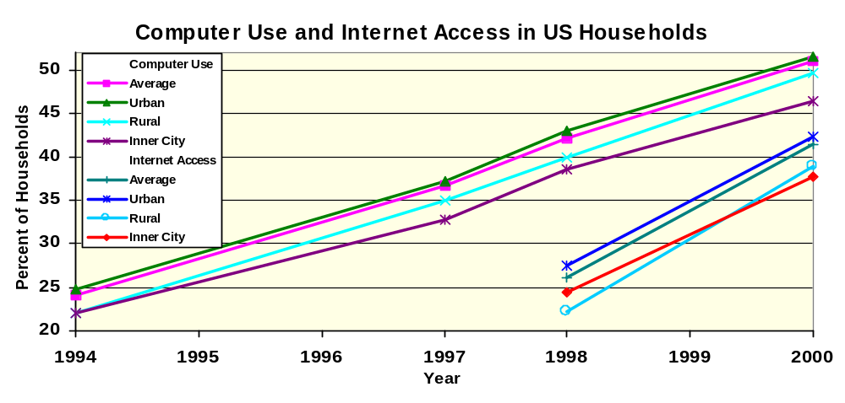
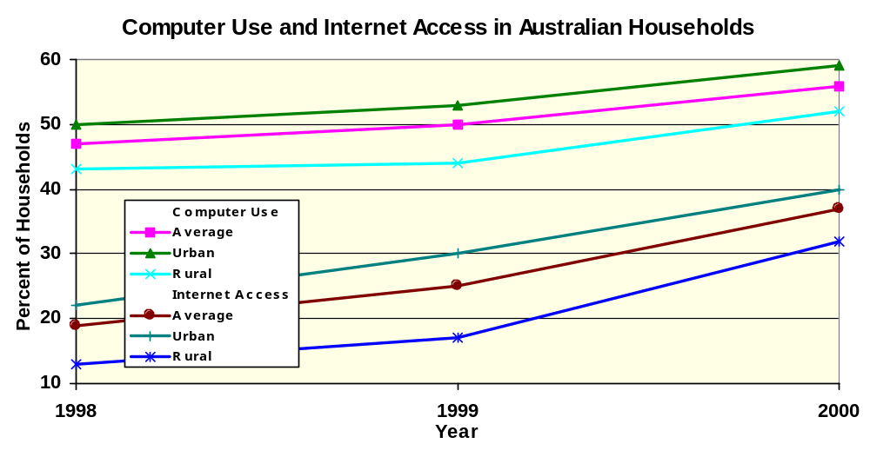
Canada has followed a very similar philosophy in its development of telecommunications, as have many other countries with large rural areas, such as Australia and New Zealand. In these countries, the concerns with rural connectivity have been dealt with in similar ways. [32] However, these countries do not have a large inner-city population, so that problem is not as much a concern. Figure 6 demonstrates that same trends seen in the United States are also seen in Australia.
Figure 5: Computer Use and Internet Access in US Households [30]
Figure 6: Computer Use and Internet Access in Australian Households [1]
In these countries, an increasing concern is the availability of broadband, or high-speed, access in rural areas. It is feared that a lack of availability of broadband in rural areas may create a new form of digital divide, as content begins to move to more data-intensive formats, such as forms laden with audio and video information. [32] There is a large cost associated with providing broadband to rural areas, because existing strategies require short distances between switching stations and the homes, which is not required for low-speed and voice connections. A solution to this problem will likely require government intervention and it is possible that the deployment of wireless solutions will be necessary.
Other countries with smaller rural areas, such as the Pacific Rim and Western Europe, do not suffer from the same problems to ensure universal access. However, in these countries, access to the Internet can be more expensive, thereby reducing penetration, due to the metered nature of their telecommunications network. In Sweden, the network is being opened to competition, the costs are dropping and Internet use is increasing. [32]
Developing nations have their own unique barriers to Internet access. In these countries, many of the previous demographic categories become far less important. Income remains an important category; however, since it impacts the vast majority of the population, it does not create a recognisable divide within the country. For example, in Bangladesh, it would take the average worker eight years to earn enough money to be able to afford a computer. [18] Even if the people were to obtain access to computers, the telecommunications infrastructure in developing nations is so poorly developed that access to the Internet would be nearly impossible. In most of these countries, there is less than one telephone line for every hundred people, [18] which are needed for access to the Internet. Of those lines that exist, most are not of sufficient quality to carry data traffic. In addition, the power system is usually also in an underdeveloped state, so access to electricity may be difficult as well. Clearly, the main problem in these countries is infrastructure. After this infrastructure is developed, income will become the largest barrier, because the people will not be able to afford to use it.
The current solutions to this problem have come in the form of foreign aid. Two major groups have been created to propose solutions to this problem and to try to generate support. The first, the DOT, or Digital Opportunity Task Force, was created in July 2000, by the Okinawa Charter on the Global Information Society during the G8 Kyushu-Okinawa Summit. [28] It has a goal of fostering international cooperation to the development of worldwide communications links, supported by the G8 nations. A plan of action has been created, and the DOT currently faces the challenge of implementing it.
More recently, the United Nations Information and Communication Technology Task Force (UNICT) was created. Its main goal is to promote universal, affordable and meaningful access to information and communication technology. [3] In this sense, its goals are similar to those of the DOT, but it is charged more with supporting efforts rather than taking direct action.
While these groups have only been around a short while, hopefully they will mark the beginning of a reduction in the global digital divide. Due to the growing importance of IT in the economies of industrialized nations, it is a necessary step for these countries to participate in the global economy.
- Conclusions
The “Digital divide” phenomenon can be studied with respect to a variety of demographic categories. These categories cover different social aspects of Internet population. They include income, education, race, religion, gender, geography, age and disabilities. The social impacts of digital divide are common among these demographic categories.
Internet access has risen in every level of income, but there is still a major gap between the high-income and low-income households connected to the Internet. Internet access is also expanding across every education level, particularly for those with some high school or college education. There is a dramatic increase in the number of Blacks and Hispanics using the Internet. The digital divide gap between men and women has disappeared, at least at home. While Internet access has risen for those demographic categories, there are others that are still relatively foreign to the Internet. People over 50 are still less likely to use the Internet. In addition, full use of the Internet is not readily available to persons with a disability.
Each of the different categories are affected by the digital divide in the same way. The most significant effect of the new information technology is in the way that people communicate. The Internet provides many forms of communication to millions of users. They range from private conversation to public announcements. Internet users in all demographic groups use many different methods of communication via the Internet. Instant messaging, e-mail, discussion forums, and news websites are just a few of the channels. Internet users can utilize these channels to have conversations, ask questions, and voice opinions.
The Internet also offers an assortment of job opportunities for users from all demographic groups. Many more job opportunities are available online than before, and those jobs are available to all the people who use the new medium of the Web. It also allows users to access information relating to education, health, entertainment and many more topics of interest.
Each of the groups that are affected by the digital divide are prevented from taking advantage of the benefits provided by the Internet. This can cause individual hardships, and can slow the economic development of a country if enough people are affected.
- Recommended Future Research
Presently, there exists a large body of research and statistics covering the existence and trends of the digital divide within industrialized nations. In these countries, large efforts are already underway to reduce the digital divide and to attempt to ensure equal opportunity for access to all. However, the factor of gender needs more exploration to determine the full extent of the issue.
Far more complicated is the situation in the developing world. While organizations have been created to begin to address this issue, far more study is necessary to determine economically feasible and effective solutions. It is recommended that future research concentrate on this aspect in order to promote global equality.

References
[1] 8147.0 Use of the Internet by Householders, Australia, Australia Bureau of Statistics, Canberra, Australia, February 2001, http://www.abs.gov.au/ausstats/abs%40.nsf/e8ae5488b598839cca25682000131612/ae8e67619446db22ca2568a9001393f8 (current: January 2002)
[2] Berczi, Andrew, MSCI 442: Impact of Information Systems on Society and Organizations, University of Waterloo, Waterloo, ON, January 2002.
[3] Bridging the Digital Divide in the 21st Century, UN Information and Communication Technology Task Force, New York, NY, November 2001, http://www.unicttaskforce.org/about/unict_taskforce_2001.pdf (current: January 2002)
[4] “Canada’s National Report to the United Nations for the 4th World Conference on Women,” Status of Women in Canada, UN Report, Ottawa, ON, 1995.
[5] Carver, Doris, Research Foundations for Improving the Representation of Women in the Information Technology Workforce, Louisiana State University, Baton Rouge, LA, 2000.
[6] Carvin, Andy, Edtech and the Presidential Race, Part 2: Al Gore’s Edtech Proposals, Benton Foundation, Washington, 2000, http://www.digitaldividenetwork.org/content/stories/index.cfm?key=18 (current: January 2002)
[7] Clinton-Gore Administration, The Clinton-Gore Administration: From Digital Divide to Digital Opportunity, The White House Office of the Press Secretary, Washington, February 2, 2000, http://www.digitaldivide.gov/2000-02-02.html (current: January 2002)
[8] Conte, Christopher, “The Learning Connection: Schools in the Information Age”, Communications Policy and Practice, Benton Foundation, Washington, November 2, 2000, http://www.benton.org/Library/Schools/ (current: January 2002)
[9] Dean, Katie, “Maine Students Hit the iBooks”, Wired, January 9, 2002, http://www.wired.com/news/school/0,1383,49046,00.html (current: January 2002)
[10] Dickinson, Paul and Jonathan Ellison, Getting Connected or Staying Unplugged: The growing use of computer communications services, Statistics Canada: Service Industries Division, Ottawa, ON, 1999.
[11] Digital Divide Basics Fact Sheet, Benton Foundation, Washington, 2001, http://www.digitaldividenetwork.org/content/stories/index.cfm?key=168 (current: January 2002)
[12] Digital Divide Network: Literacy and Learning, Benton Foundation, Washington, DC, 2001, http://www.digitaldividenetwork.org/content/sections/index.cfm?key=4 (current: January 2002)
[13] Drygulski-Wright, Barbara, ed, Women, Work, and Technology, University of Michigan Press, Ann Arbor, MI, 1990.
[14] Fine, Ben, Women’s Employment and the Capitalist Family, Routledge, London, England, 1992.
[15] Fox, Susannah, et al, Wired Seniors: A Fervent Few, Inspired by Family Ties, Pew Internet & American Life Project, Washington, DC, September, 2001, http://www.pewinternet.org/reports/pdfs/PIP_Wired_Seniors_Report.pdf (current: January 2002)
[16] Goyder, John, Technology and Society: A Canadian Perspective, Broadview Press, Peterborough, ON, 1997.
[17] Hubbard, Lee, “Is the digital divide a black thing?” Salon News, March 2, 2000, http://www.salon.com/news/feature/2000/03/02/digital/ (current: January 2002)
[18] Jolly, Richard, Human Development Report, 1999, United Nations Development Programme, New York, NY, 1999, http://www.undp.org/hdro/report.html (current: January 2002)
[19] Lenhart, Amanda, et al, Teenage Life Online, Pew Internet & American Life Project, Washington, DC, June, 2001, http://www.pewinternet.org/reports/pdfs/PIP_Teens_Report.pdf (current: January 2002)
[20] Lenhard, Amanda, et al, Who’s not Online, Pew Internet & American Life Project, Washington, DC, September, 2000, http://www.pewinternet.org/reports/pdfs/Pew_Those_Not_Online_Report.pdf (current: January 2002)
[21] Letemendia, Claire, “The Digital Divide, Part one: a Web for everyone?” Canada Computes, August 16, 2000, http://www.canadacomputes.com/v3/story/1,1017,3077,00.html?tag=81&sb=121 (current: January 2002)
[22] Menzies, Heather, Whose Brave New World: The information highway and the new economy, Between the Lines, Toronto, ON, 1996.
[23] Mission Statement, The Alliance for Technology Access, San Rafael, CA, http://www.ataccess.org/about/mission.html (current: January 2002)
[24] Margolis, J., et al, “Caring about connections: Gender and Computing,” IEEE Technology and Society Magazine, pp 13-20, Winter 1999.
[25] National Telecommunications and Information Administration, Falling Through the Net: Defining the Digital Divide, U.S. Department of Commerce, December, 1998, http://www.ntia.doc.gov/ntiahome/fttn99/contents.html (current: January 2002)
[26] Newburger, Eric, Home computer use and Internet use in the United States: August 2000, American Census Bureau, September 2000, http://www.census.gov/prod/2001pubs/p23-207.pdf (current: January 2002)
[27] Novak, Thomas and Donna Hoffman, Bridging the Digital Divide: The Impact of Race on Computer Access and Internet Use, Vanderbilt University, February 2, 1998, http://www2000.ogsm.vanderbilt.edu/papers/race/science.html (current: January 2002)
[28] Okinawa Charter on Global Information Society, Government of Japan, July 2000, http://www.dotforce.org/reports/it1.html, (current: January 2002)
[29] Page, D., “Building the Digital Bridge in Boston,” Converge Magazine, Folsom, CA, December, 2000, http://www.convergemag.com/Publications/CNVGDec00/buildingDigital.shtm (current: January 2002)
[30] Rohde, Gregory, et al, Falling Through the Net: Toward Digital Inclusion, US Department of Commerce, Washington, DC, October 2000, http://www.ntia.doc.gov/ntiahome/fttn00/contents00.html (current: January 2002)
[31] Smith, M. Dayle, Women at Work: Leader for the Next Century, Prentice Hall, New Jersey, 2000.
[32] The Availability and Affordability of Internet Infrastructure in Rural Areas of Canada and its Implications for E-Commerce Development, DMA Consulting, December 2000, http://broadband.gc.ca/english/resources/nbtf_dma_report.pdf (current: January 2002)
[33] Waddell, Cynthia D., Applying the ADA to the Internet: A Web Accessibility Standard, City of San Jose, San Jose, CA, June 17, 1998, http://www.rit.edu/~easi/law/weblaw1.htm (current: January 2002)
[34] Waddell, Cynthia D., The Growing Digital Divide in Access for People with Disabilities: Overcoming Barriers to Participation in the Digital Economy, San Jose Office of Equality Assurance, San Jose, CA, May 25, 1999, http://www.aasa.dshs.wa.gov/access/waddell.htm (current: January 2002)
[35] Young, Jeffrey, “Does 'Digital Divide' Rhetoric Do More Harm Than Good?” The Chronicle of Higher Education, November 9, 2001, http://chronicle.com/free/v48/i11/11a05101.htm (current: January 2002)

Appendix A: Presentation Slides

